Ideation Phase
Define the Problem Statements

Date | 18 February 2026
Team ID | LTVIP2026TMIDS80016
Project Name | Flavor Fusion: AI- Driven Recipe Blogging
Maximum Marks | 2 Marks

Customer Problem Statement Template:
Create a problem statement to understand your customer's point of view. The Customer Problem Statement template helps you focus on what matters to create experiences people will love.
A well-articulated customer problem statement allows you and your team to find the ideal solution for the challenges your customers face. Throughout the process, you’ll also be able to empathize with your customers, which helps you better understand how they perceive your product or service.


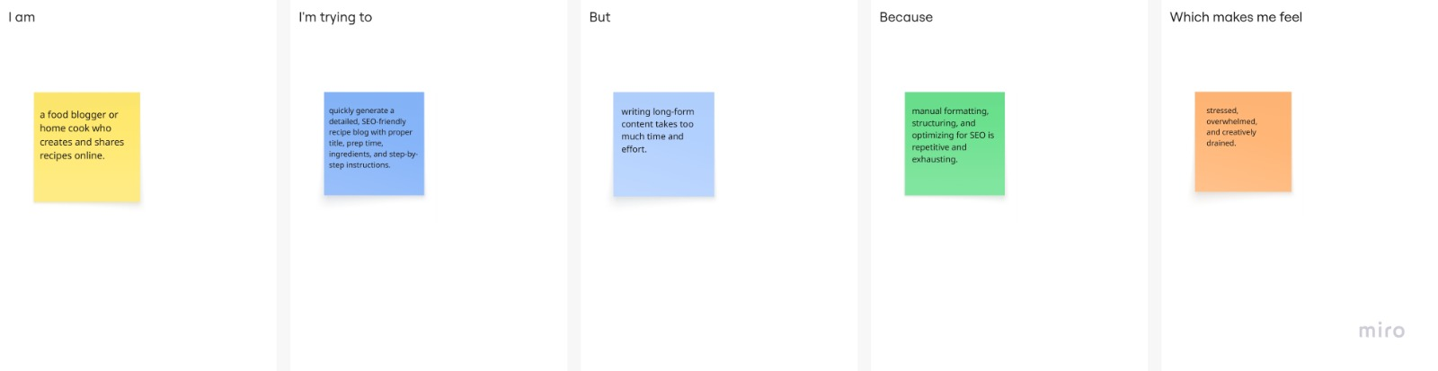
Problem Statement (PS) | I am (Customer) | I’m trying to | But | Because | Which makes me feel
PS-1 | a food blogger or home cook who creates and shares recipes online. | quickly generate a detailed, SEO-friendly recipe blog with proper title, prep time, ingredients, and step-by-step instructions. | writing long-form content takes too much time and effort. | manual formatting, structuring, and optimizing for SEO is repetitive and exhausting. | stressed, overwhelmed, and creatively drained
PS-2 | a home cook with limited ingredients available. | figure out what dish I can prepare using what I already have. | I don’t know which recipes match my ingredients. | most platforms require exact recipe names instead of ingredient-based suggestions. | confused and frustrated.
PS–3 | a food blogger who wants reliable AI assistance. | use AI to generate accurate, food-focused content. | I worry that AI might generate incorrect or imaginary ingredients. | general AI tools are not restricted to culinary knowledge. | uncertain and hesitant to trust the output.

